28.77: 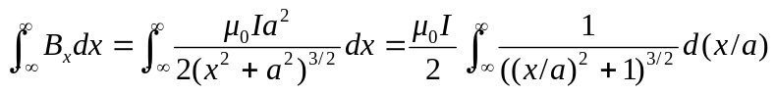
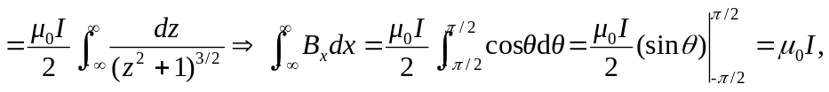
where we used the substitution 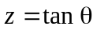 to go from the first to second line. This is just what Ampere’s Law tells us to expect if we imagine the loop runs along the x-axis closing on itself at infinity: 